Title: Issues, Groups, Or Idiots? Comparing Theories of Partisan Stereotypes

Running Header: Comparing Theories of Partisan Stereotypes

Author:
C. Daniel Myers
Department of Political Science
University of Minnesota
1414 Social Sciences Building
267 19th Ave S
Minneapolis, MN 55455
612-626-8938
cdmyers@umn.edu

Word Count: 6488

Version accepted for publication at Public Opinion Quarterly.
Online Appendices available here: https://1e74260a-5549-4e3a-893a-1108a48d6939.usrfiles.com/ugd/1e7426_d10951fdb04a439cbdfde4a8ef6716dc.docx
Replication archive available here: https://hdl.handle.net/11299/250201

Author Note:

C. Daniel Myers is an Assistant Professor of Political Science at the University of Minnesota, Minneapolis, MN. The author thanks Kirill Zhirkov, Kristin Lunz Trujillo, Ethan Busby, Adam Howat, Chris Federico, Paul Goren, Howard Lavine, Eugene Borgida, Brian Schaffner, participants in the University of Minnesota Center for the Study of Political Psychology Colloquium, University of Minnesota Political Methodology Colloquium, and in the 2019 Meeting of the American Political Science Association panel on "Social Groups, Social Identities, and Politics" for helpful feedback and commentary on earlier drafts of this paper. This work was funded by a Seed Grant for Social Science Research from the University of Minnesota College of Liberal Arts. The author declares that he has no conflicts of interest. Address correspondence to C. Daniel Myers, Department of Political Science, University of Minnesota, 1414 Social Sciences Building, 267 19th Ave S, Minneapolis, MN 55455, USA; email: cdmyers@umn.edu.

Abstract:
When individuals picture the two parties, what do they think of? Given the dominant understanding of partisanship as a social identity, understanding the content of these mental images – individuals’ stereotypes of the two parties – is essential, as stereotypes play an important role in how identity affects attitudes and behaviors, perceptions of others, and inter-group relations. The existing literature offers three answers to this question: one that claims that people picture the two parties in terms of their constituent social groups, a second that claims that people picture the two parties in terms of policy positions, and a third that claims that people view the two parties in terms of individual traits they associate with partisans. While not mutually exclusive, these theories have different implications for the effects of partisanship and the roots of partisan animosity. This paper adjudicates between these theories by employing a new method that measures stereotype content at the collective and individual level using a conjoint experiment. An important advantage of the conjoint measure is that it allows for the direct comparison of the importance of different attributes, and different kinds of attributes, to the stereotype. Using a pre-registered 2,909-person survey, I evaluate the relative importance of issues, groups, and traits to stereotypes of partisans. I find strong evidence that issue positions and ideological labels are the central elements of partisan stereotypes. I also find that individuals who hold issue or ideology-based stereotypes are more affectively polarized than those whose stereotypes are rooted in groups or traits.

Political scientists increasingly view America’s contentious politics through the lens of Social Identity Theory (Greene 2004; Iyengar et al. 2012; Mason 2018). According to this view, contemporary American politics are so divisive not because of greater ideological disagreement, but because a variety of trends have led Americans to identify more strongly as partisans (Iyengar et al. 2019). This identification leads citizens to view normal political disagreement as an “us vs. them” conflict between an in-group and an out-group. Given this understanding of contemporary partisanship, it is critical to understand how people perceive the political parties as social groups. What defines “us” and what defines “them”? In other words, what is the content of our partisan stereotypes?
Existing research offers three different answers to this question; while not mutually exclusive, each answer highlights a different kind of attribute as central to partisan stereotypes. First, some work assumes that the mass public pictures parties in terms of their constituent social groups (Green et al. 2002; Ahler and Sood 2018; Kane et al. 2021). A second body of work argues that partisans are defined in terms of their positions on high-profile issues or the ideological labels they adopt (Webster and Abramowitz 2017; Orr and Huber 2020). Finally, some recent work argues that the parties are defined directly in terms of traits their members are thought to possess (Busby et al. 2021). Partisan stereotypes might also be a combination of these. Put differently, when a typical Democrat thinks about a typical Republican, do they picture an old white man, a self-interested, prejudiced, and closed-minded person, a conservative who opposes abortion, or some mixture of these three?
The answer to this question is important because individuals’ partisan stereotypes determine how partisans perceive themselves and each other. Stereotypes of groups have long been recognized as playing a central role the affect we feel towards social groups, the way we categorize individuals and use these categories to draw inferences about them, and how our own group identities affect our beliefs, behaviors, and self-concept (Bodenhausen et al. 2012). In line with these expectations, a range of recent studies tie the content of partisan stereotypes to inter-party animosity. However, these studies are grounded in different assumptions about the content of party stereotypes and offer conflicting findings about what stereotype content is associated with affective polarization. For example, proponents of the group-based theory claim that affective polarization is driven by strong (and often inaccurate) associations between the parties and disliked social groups (Ahler and Sood 2018; Kane, et al. 2021; Claussen et al. 2021). In contrast, proponents of an issue-based understanding of partisanship argue that this dislike is actually rooted is policy disagreement (Orr and Huber 2020), while work advancing the trait-based understanding of partisanship associating the out-party with disliked traits is most closely related with affective polarization (Busby et al. 2021).
We evaluate the relative importance of these different kinds of attributes to partisan stereotypes and their relationship with affective polarization with a new technique that measures stereotype content using a conjoint experiment. Conjoint experiments, most frequently used to measure choice, have more recently been adapted to measure the content of stereotypes of social groups (Flores and Schacter 2018; Myers et al. 2022). Measuring stereotypes content using a conjoint experiment allows us to compare the importance of different attributes simultaneously and on the same scale, making it possible to compare the relative importance of different kinds of attributes. We draw on this strength to adjudicate between competing claims about the relative role of groups, issues, and traits to partisan stereotypes. Drawing on an original pre-registered survey of a 2,941-person nationally-representative non-probability sample, we evaluate the importance of 17 attributes to stereotypes of partisans. We also compare stereotype content across partisan subgroups to see if Republicans and Democrats hold similar stereotypes. Finally, we estimate the content of individuals’ stereotypes (Zhirkov 2022) and measure their relationship with polarization. We find strong evidence that issues and ideological labels, rather than groups or traits, play the central role in stereotypes of partisans. Further, we find that individuals who hold issue-based stereotypes are more polarized affectively, ideologically, and perceptually, than those who hold group or trait-based stereotypes.

Functions of Party Stereotypes
Stereotypes are knowledge structures that allow individuals to store general information about groups, and shape how individuals perceive out-groups, other individuals, and themselves. At the intergroup level, an individual’s stereotype of an out-group is highly related to their affect toward that group (Esses et al. 1993). At the interpersonal level, stereotypes are used to categorize unknown individuals by matching observed attributes of the individual to the attributes that comprise the stereotype, particularly those that are central to the stereotypes. Once categorized, the perceiver’s stereotype is used to draw inferences about an individuals’ other attributes (Bodenhausen et al. 2012). Finally, stereotypes play an important role in individual’s self-perception through the process of self-stereotyping (Turner 1987). Individuals determine how well they fit with a group based on their stereotype of the group, and identification with a group motivates individuals to define themselves in terms of the attributes central to their stereotype of that group.
All of these processes have important implications for the role of partisanship and can help understand a range of recent work on the role of partisan identity in political behavior. Most recent work has focused on the intergroup effects of partisan stereotypes, specifically how party images are related to affective polarization (Ahler and Sood 2018; Mason and Wronski 2018; Robison and Moskowitz 2019; Busby et al. 2021). Less work has focused on the inter-personal level, though an individual’s partisan stereotypes have been found to affect their willingness to engage in interpersonal interaction (Lee 2021). And while relatively little work has drawn on self-stereotyping to explain the acquisition of and effects of partisanship (though see Patrikios 2013; Han and Wackman 2017), claims that individuals determine their partisanship by comparing themselves to their stereotypes of the two parties (Green et al. 2002, pg. 7-11) as well as findings that partisanship can shape religious identity (Margolis 2018) can be interpreted through this lens. In short, by defining what it means to be “us” and what it means to be “them,” the content of partisan stereotypes mediates the effect of partisan identity on political cognition and behavior.

Theories of Party Stereotypes
What, then, is the content of partisan stereotypes? Existing work describes three different categories of attributes that might be part of party stereotypes. Following Busby et al. (2021), we describe these as three different theories of partisan stereotypes: a group-based theory, which holds that members of the mass public think of the parties in terms of their constituent social groups, a trait-based theory, which argues that the parties are basic social categories in their own right defined by the traits associated with individual partisans, and an issue-based theory, which holds that members of the mass public think of the parties in terms of the issue positions they hold. These three theories are not mutually exclusive – individuals’ partisan stereotypes may contain a mixture of different kinds of attributes, and the content of stereotypes may differ across members of the mass public. However, most existing work on party images either explicitly or implicitly assumes that party images can be categorized in terms of one of these kinds of attributes.

Group-Based Stereotypes of Parties
Currently, most prominent work on the content and role of party images assumes, implicitly or explicitly, that partisan stereotypes consist primarily of the social or demographic groups associated with the party (Green et al. 2002; Mason and Wronski 2018; Kane et al. 2021). This work, described by Busby et al. (2021) the coalitional model and Kane et al. (2021) as the groups approach, is closely related to the long tradition that sees the parties themselves as superordinate groups made up of more basic, non-political identities (Campbell et al. 1960, Green et al. 2002). A corollary of the claim that parties are amalgamations of social groups is that parties are perceived by members of the mass public in terms of their constituent social groups. Green et al. (2002, pg. 8) state this claim most explicitly, defining an individual’s partisan stereotypes as “What kinds of social groups come to mind as I think about Democrats, Republicans, and Independents?” Ahler and Sood (2018, pg. 965) term these stereotypes the parties’ “Sociopolitical Brands” suggesting that “when thinking about the parties, one may call to mind a Southern, evangelical Republican or a young, nonwhite Democrat.”
Evidence for this view can be found in recent work that shows a connection between feelings towards partisans and feelings towards the groups that are thought to make up that party. Partisans who feel closer to groups aligned with their party have higher in-party feeling thermometer scores (Mason and Wronski 2018), and feelings towards partisan-aligned groups affect the strength of partisan identification and affect towards the parties (Robison and Moskowitz 2019; Kane et al. 2021; Claussen et al. 2021). Ahler and Sood (2018) find that misperceptions about the demographic composition of the parties produces hostility towards the out-party and leads respondents to overestimate the out-party’s ideological extremity (Ahler and Sood 2018; cf. Orr and Huber 2021).

Partisan-Trait Based Stereotypes of Parties
A second theory argues that the parties are not just seen as coalitions of other social identities, but also as social identities in their own right. Under this theory, parties are basic social categories, defined directly by the perceptions of the characteristics party members tend to have; Busby et al. (2021) call this the partisan-identity view of partisanship. Building on work on trait-ownership (Hayes 2005), this view argues that members of the mass public associate particular traits like “caring” or “patriotic” with partisans (Clifford 2020; Busby et al. 2021). While political scientists are accustomed to thinking about parties as defined by their subordinate groups, most work on stereotypes of other kinds of groups define these stereotypes in terms of individual-level characteristics associated with members of the stereotyped group (e.g. Katz and Braley 1933, Diekman and Eagly 2000).
Recent evidence for this view comes from Busby et al (2021; Rothschild et al. 2019), who analyze open-ended responses to a prompt asking for descriptors of the two parties and find that approximately twice as many people describe the parties in terms of “trait” stereotypes as in terms of what they term “issues/groups” stereotypes. Further, they find that individuals who hold “trait” stereotypes are more polarized and perceive more polarization. Similarly, Clifford (2020) finds that individuals associate different traits with the two parties. This view is also supported by work suggesting that members of the mass public view in-partisans and out-partisans negatively because they stereotype them “highly-engaged ideologues” (Druckman et al. 2022), who talk about politics frequently (Klar et al. 2018). While being politically engaged is a different kind of trait than those identified by Busby et al. (2021), it is still an attribute that is associated with the partisan group directly, not via one of the groups that comprise the party’s coalition.

Issue-Based Stereotypes of Parties
A third theory of partisan stereotypes, referred to by Busby et al. (2021) as the instrumental view of partisan stereotypes, focuses on issue stances or priorities. The earliest work to explicitly discuss party images as stereotypes found an association between issue positions and party stereotypes and showed that these stereotypes affected information processing and candidate evaluation (Rahn 1993). This work was in line with contemporaneous theories of partisanship as a heuristic that substituted for detailed political knowledge (Popkin 1991), work demonstrating the role of issue positions and ideology in the acquisition of partisanship (Niemi and Jennings 1991), and theories of issue ownership (Petrocik 1996).
More recently, Goggin and Theodoridis (2017) find that voters apply stereotypes about party issue reputations when judging the competence of hypothetical candidates, but do not attribute traits associated with the parties to that party’s candidates. Similarly, Goggin et al. (2020) use a conjoint experiment to show that voters draw on associations related to issue ownership to judge whether a candidate is a Democrat or a Republican. A separate line of work finds that information about an individuals’ policy views reduces the effect of partisanship on affect towards that individual (Orr and Huber 2020; Druckman et al. 2022), that issue positions have a larger effect on candidate evaluation than party (Lelkes 2021), and that partisans value policy congruence over affective statements when evaluating representatives (Costa 2021). If individuals evaluate and form affective judgements towards others based on their policy views or ideological position, then these factors may also play a central role in stereotypes of partisans.

Ideology and Ideological Labels
Finally, individuals may stereotype partisans in terms of ideology, or at least ideological labels, but existing work disagrees about what “kind” of attribute ideology is. Building on theories of symbolic ideology (Ellis and Stinson 2012), group-based theorists often treat ideological labels as another group identity that can become associated with partisanship (Mason 2018). On the other hand, issue-based theorists treat ideological sorting as evidence against social identity theories of partisanship (Abramowitz and Saunders 2006; Webster and Abramowitz 2017), or use the word “ideology” as synonymous with issue positions (Orr and Huber 2020; Lelkes 2021). Finally, these labels may also function as traits associated with the partisans; Busby et al. (2021) find that “liberal,” and “conservative” are listed more frequently by respondents asked to list Republicans’ and Democrats’ “personality and character traits,” than by those asked to list issues or groups. We treat ideological labels as their own type of attribute, but also analyze the implications of treating them as a “group,” “issue,” or “trait” attribute.

Competing Theories of Partisan Stereotypes
Existing studies tend to assume that partisan stereotypes are made up of one of these types of attributes, making it impossible to judge the relative importance of each type. For example, Ahler and Sood (2018)’s study of misperceptions of the composition of the parties asks only about demographic groups and not perceptions of the traits or issue positions of partisans. Conversely, Druckman et al. (2022) measure perceptions of the typical partisans’ ideological views and engagement with politics, but not about the group composition of the parties. In both cases, no attention is paid to attributes thought to be important by the missing theor(ies).
This presents two problems. First, this makes it impossible to ascertain which of these attributes, and which kind of attribute, is more important to the partisan stereotype. Second, the direct questioning techniques used by these studies, and the fact that they only ask about one or at most two kinds of attributes, means that they may artificially inflate the importance of the specific attributes they ask about. For example, Ahler and Sood (2018) find that Democrats overestimate the percentage of Republicans who are over 65. Perhaps this is because, in line with group-based theories of partisanship, “old” is a central part of the stereotype of Republicans. Or perhaps “conservative” is the central element of the stereotype of Republicans, but when asked only about the percent of Republicans who are over 65, Democrats infer from their stereotype of Republicans as conservative that they are also older on average.
The exception to this is work by Busby et al. (2021), who explicitly theorize that partisan stereotypes vary across individuals. As described above, these authors use open-ended questions that ask respondents to list “four words that typically describe people who support the <Republican/Democratic> party;” using a structural topic model they sort individuals’ responses into a series of “topics,” each representing a stereotype. This open-ended approach offers a valuable exploration of the content of partisan stereotypes. However, it is limited in its ability to estimate the relative importance to partisan stereotypes of different attributes and thus to adjudicate between competing theories of partisan stereotypes. Open-ended responses rely on individuals to report their own stereotypes in response to direct questioning. Further, the open-ended questions used by Busby et al. (2021) solicit only four one-word descriptors to describe each party, limiting the information available to characterize each individual’s stereotypes. Busby et al. (2021) attempt to label each topic produced by their structural topic model in terms of the type of stereotype it describes, but label half of all respondents as having “ambiguous” stereotypes and cannot distinguish between issue-based and group-based stereotypes. Thus, while open-ended questions are a useful way to describe the content of stereotypes in an inductive fashion, other methods are needed to judge the relative importance of different attributes to these stereotypes and the degree to which the different kinds of stereotypes described above actually exist in the population as a whole.
One such method is a conjoint experiment (Myers et al. 2022). Conjoint experiments present a respondent with profiles that describe some political object in terms of multiple attributes, each with multiple possible values, and then ask the respondent to choose between profiles or rate them on some scale. Because the value of each attribute is independently drawn, these ratings can be used to measure the effect of each attribute-value on the choice or rating, the Average Marginal Component Effect (AMCE). Conjoint experiments were introduced to measure the effect of attributes on choice, such as vote choice (Hainmueller et al. 2014). However, several recent studies have used conjoint experiments to measure the content of stereotypes of groups (Flores and Schacter 2018; Myers et al. 2022). By asking respondents to rate how typical the person described in the profile is of the group in question, the resulting AMCEs can be interpreted as a measure of the importance of the attribute to the stereotype. While relatively new, this method builds on well-established paradigm of measuring group stereotypes by asking people to rate the typicality of individual members of the group (Garcia-Marques et al. 2006; Heit and Nicholson 2010; Nicholson et al. 2018).
The conjoint measure of stereotype content has a number of advantages. Most importantly, for the purpose of judging the contribution of each theory of partisan stereotypes, it can measure the effect of many different attributes – and different kinds of attributes – simultaneously. This is an improvement over past studies that include only a few attributes, or only one kind of attribute. The conjoint experiment can also directly compare the effect of attributes on the same scale, allowing for a straight-forward test of which is more important. By comparing subgroup estimates of the effect of each attribute, we can evaluate whether stereotypes of the parties are shared across partisan sub-groups. Additionally, the conjoint task, which asks respondents to categorize individual exemplars, resembles an important cognitive function of stereotypes, while methods that use direct questioning rely on respondents to access and accurately report their own stereotypes. Finally, conjoint experiments reduce social desirability bias (Horiuchi et al. 2021).
Two existing studies use conjoint experiments to measure mental associations between attributes and partisanship. Ogura et al. (2022) asks respondents to judge the partisanship and strength of partisanship of individuals described in terms of their political participation, parental partisanship, vote choice, agreement with their party’s “positions on recent political issues,” and whether they take criticism of the party as a personal insult. They find the largest effects from the vote choice, policy agreement, and participation in party activities attributes. Unlike the present study, Ogura et al. (2022) describe policy agreement in terms of general agreement with the party, not positions on specific issues, and do not include any group or trait attributes. Goggin et al. (2020) describe candidates for office in terms of issue positions and demographic attributes and ask respondents to guess the candidates’ partisanship. However, their study focuses on a small number of attributes, including only issue priorities (but not positions) and explicitly excludes group attributes like race because they are thought to be central to partisan stereotypes. Our work builds on these studies by including a more complete set of attributes that may be part of the partisan stereotype, and by asking respondents to judge how typical individuals are of Republicans/Democrats instead of asking them to guess the partisanship of the individual.

Method

Conjoint Design
The profiles in our conjoint design contain four categories of attributes: groups, issue positions, traits, and ideological labels. In each category, we attempt to include the attributes found or theorized to be the most important to party stereotypes – in addition to our substantive interest in comparing the importance of attributes highlighted in the existing literature, this addresses concerns about information equivalence (Dafoe et al. 2018). We draw on the open-ended responses from Busby et al. (2021), a 2021 replication of their survey (Busby et al. 2022), and attributes measured in previous studies of partisan stereotypes. Appendix B describes the attribute selection process in detail.

“Groups” Attributes
Race | White, Black, Hispanic
Gender | Female, Male
Age | Uniform distribution 25-85 (Grouped to 24-44, 45-64, 65+
Income-level | Rich, Middle-Class, Poor
Religion | Evangelical Protestant, Mainline Protestant, Catholic, Agnostic, Atheist, Nothing in Particular
Education | High school degree, Some college, no degree, Undergraduate degree, Graduate degree
“Traits” Attributes
Traits are paired into opposites | Honest, Dishonest  Open-minded, Closed-minded  Caring, Selfish  Smart, Ignorant  Hard-working, Lazy
 | Patriotic, Unpatriotic
Talks About Politics | Rarely, Occasionally, Frequently
“Issues” Attributes
Abortion | Abortion should be legal, Abortion should be Illegal
Immigration | Immigration is Good for the US, Immigration is Bad for the US
Tax Cuts | Taxes should be cut for everyone, Taxes should be raised, especially for the rich
Ideological Labels | Extremely Conservative, Conservative, Slightly Conservative, Moderate, Slightly Liberal, Liberal, Extremely Liberal
Table 1: Attributes and Values for Conjoint Experiment

For demographic groups we listed Race/Ethnicity, Gender, Age, Income-level, Religion, and Education. For issue positions, we list general positions on three issues that capture the economic and social dimensions of partisan disagreement: taxes, abortion, and immigration. For traits we created pairs of traits from a list of the most common traits reported in Busby et al. (2021)’s data and the frequency with which an individual talks about politics. For ideology, we use the seven levels of the ANES ideological scale. The order of all types of attributes, as well as the order of attributes within each type, was randomized for each respondent, but stayed the same across all tasks competed by the respondent.
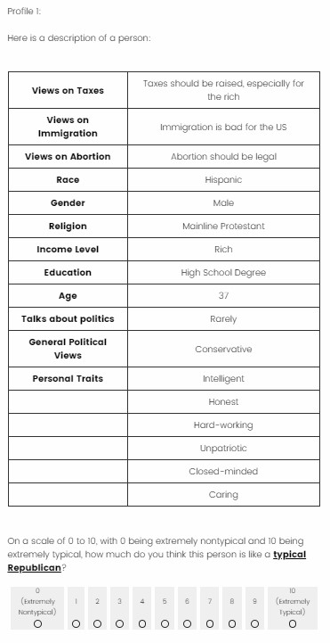
Figure 1: Conjoint Task Example. An example of the conjoint task completed by respondents.

We introduced the conjoint task using language adapted from Druckman et al. (2022)’s prompt to elicit responses about partisans in the mass public: “In the following screens, we are going to ask you a series of questions about ordinary people (e.g. voters) who are <Republicans/Democrats>. On each screen, you will be shown a profile of a hypothetical individual. After reviewing the profile, please rate how much you think this person is like a typical <Republican/Democrat>.” Next, respondents rated the 30 profiles of one party. Figure 1 shows the task format and wording. We deviate from standard conjoint practice by showing one profile at a time because this better mirrors a cognitive function of stereotypes – person categorization.

Survey Design
Our sample of survey respondents is recruited from LUCID, a provider of nationally representative non-probability samples that previous work has found to match results from other, probability samples (Coppock and McClellan 2019). To address concerns about inattentiveness in respondents from online panels (Kennedy et al. 2021), we employ four attention checks items, detailed in Appendix L. 51 percent of respondents who consented to participate passed these attention checks, providing a final sample of 2,909 respondents. Data collection ran from Dec 3, 2021 – Feb 7, 2022.
Respondents also completed a block of questions measuring affective, perceived, and ideological polarization, and a block of questions measuring party ID strength, political knowledge, and political interest. We randomize the order of the conjoint block and the polarization block and always ask the strength/knowledge/interest questions last. We use Lucid’s standard data delivery to measure demographic variables and party identification, recoding leaners as partisans.

Analysis
To evaluate which attributes, and which kind of attributes, are more central to partisan stereotypes we estimate each attribute’s AMCE for stereotypes of Republicans and stereotypes of Democrats using an OLS model with standard errors clustered by respondent. To evaluate which kind of attribute is more important, we estimate four non-nested models, each containing one category of attributes. We use pairwise Vuong (1989) tests to compare the fit of each pair of models. Finding that one model has better fit than another supports the hypothesis that that first kind of attributes is more central to the stereotype than the second kind of attribute. To evaluate the relationship between individuals’ stereotypes and their degree of polarization, we follow Zhirkov (2022)’s procedure for estimating Individual Marginal Component Effects (IMCEs). IMCEs make use of the fact that respondents rated a large number of profiles to estimate the effect of each attribute-level on typicality judgements for each individual. IMCEs can be interpreted at the individual level in the same way that AMCEs are at the aggregate level.

Results
Figures 2 and 3 show the AMCE of each attribute for Democrats and Republicans among all respondents. Stereotypes of partisans show a clear pattern across the different types of attributes: issues and ideological labels play the largest role, followed by traits, and groups. Views on abortion and immigration along with ideological labels are the most important attributes for stereotypes of both parties. Some group and trait attributes achieve statistical significance. For stereotypes of Democrats, “Nothing in Particular” is significantly more typical than other religious categories, though other non-religious categories are not, while being closed-minded, dishonest, or unintelligent is significantly less typical. For stereotypes of Republicans, income-level affects typicality judgements with rich most typical followed by middle-class followed by poor, while white profiles are judged more typical than non-white profiles and atheists significantly less typical than being catholic or evangelical protestant. Patriotism is the trait most closely associated with Republicans, while profiles labeled dishonest, unintelligent, and lazy were judged less typical. Still the effect of all of these attributes pales in comparison to the effect of ideology or issue positions. The point estimate of the effect of the least important issue position (taxes) is greater in magnitude than that of any demographic group or trait.

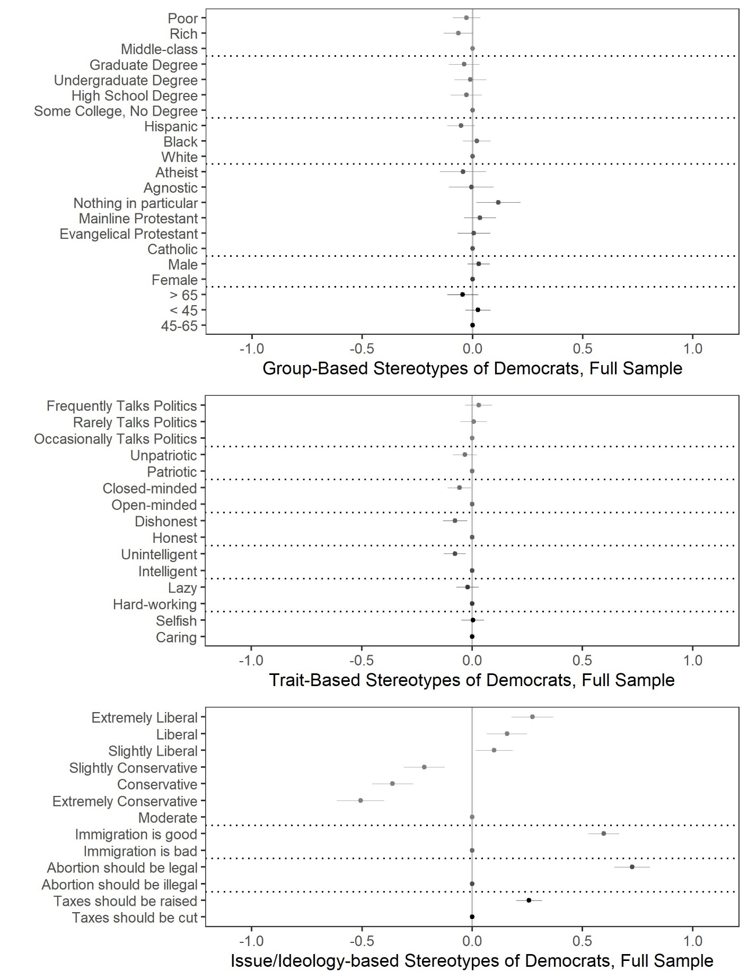
Figure 2: Content of Stereotypes of Democrats (AMCEs of Attributes). The AMCE of each attribute for respondents asked to rate the typicality of Democrats. The AMCEs for ideological labels and issue positions are larger than those for issues or groups.
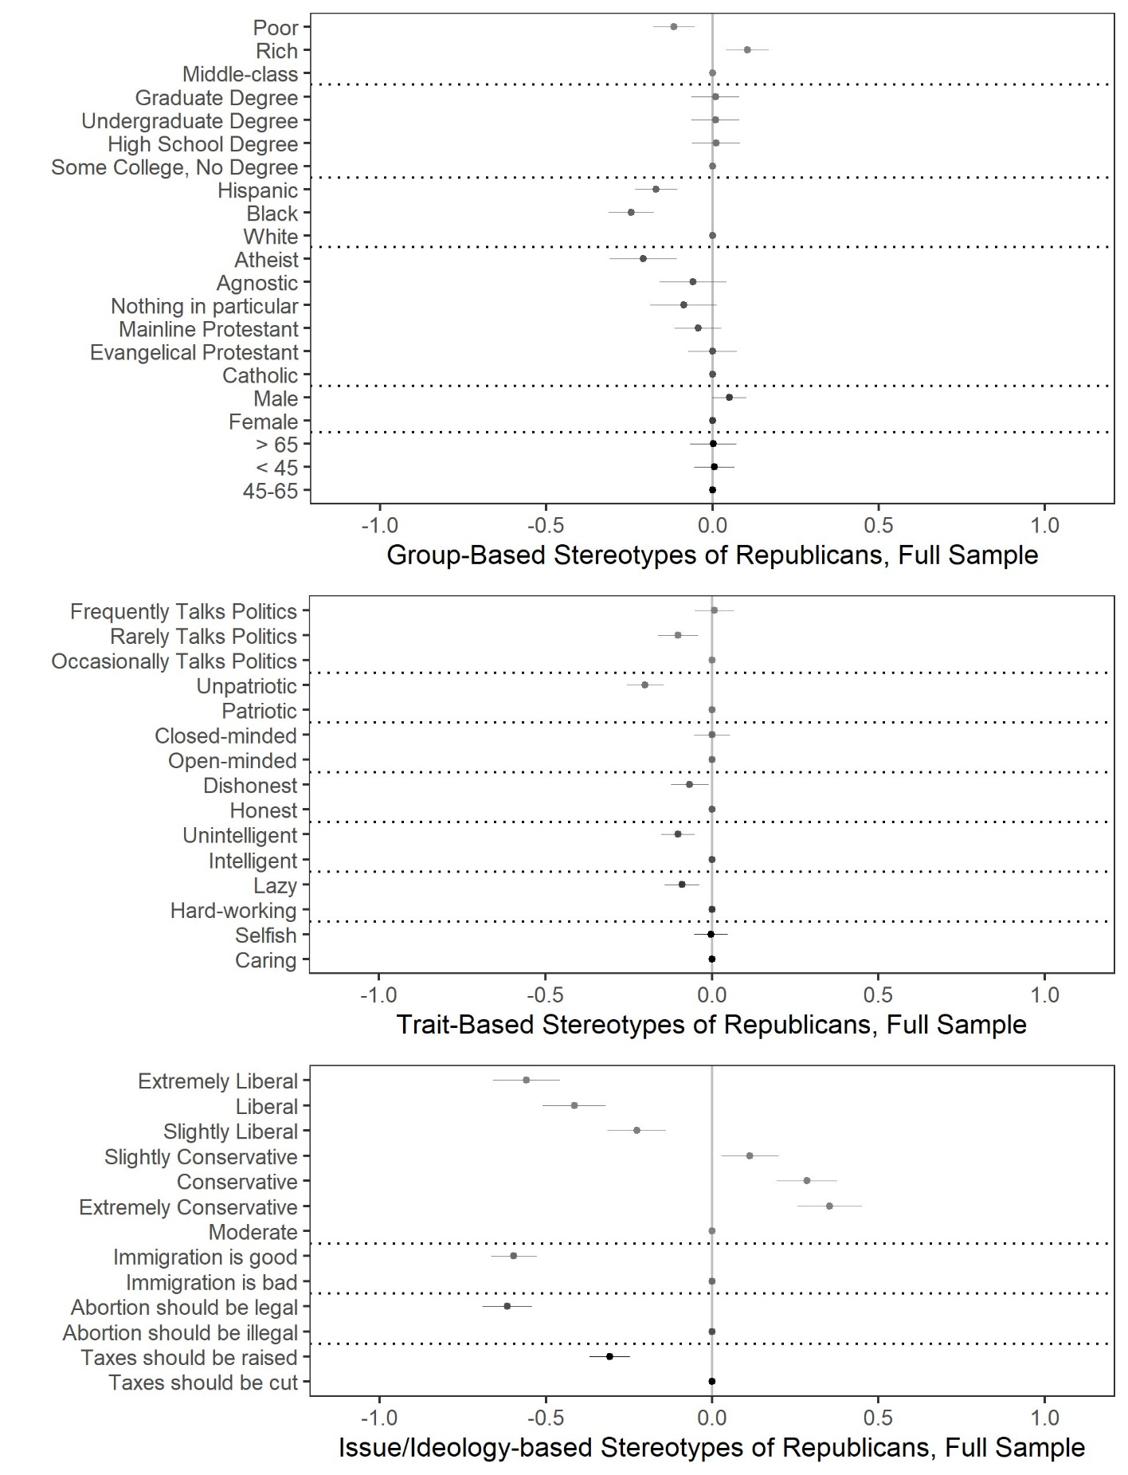Figure 3: Content of Stereotypes of Republicans (AMCEs of Attributes). The AMCE of each attribute for respondents asked to rate the typicality of Republicans. The AMCEs for ideological labels and issue positions are larger than those for issues or groups.

Figures 4 and 5 show AMCEs by partisan subsample. As with the full-sample results, issues and ideology play a larger role than groups or traits. Figures 6 and 7 show the difference in AMCE between partisan subsamples, allowing for evaluation of whether stereotypes of Democrats and Republicans are shared. Figure 6 suggests that this is largely true for stereotypes of Republicans, the exception being that Democrats judge Black profiles to be less typical of Republicans than white profiles. Stereotypes of Democrats are less consensual. Republicans’ stereotypes of Democrats appear more rooted in issues and ideological labels than Democrats’ stereotypes of themselves. Democrats do not judge liberal profiles to be more typical of their party than moderate profiles, while Republicans judge liberal, and especially “extremely liberal,” to be much more typical. Additionally, positions on immigration and taxes are more important to the Republican stereotype of Democrats, though these issues play a large role in both parties’ stereotypes of Democrats. Both sets of partisans are slightly more willing to judge profiles with negative traits as typical of the out-party than of the in-party, but there is little difference in this tendency across traits.
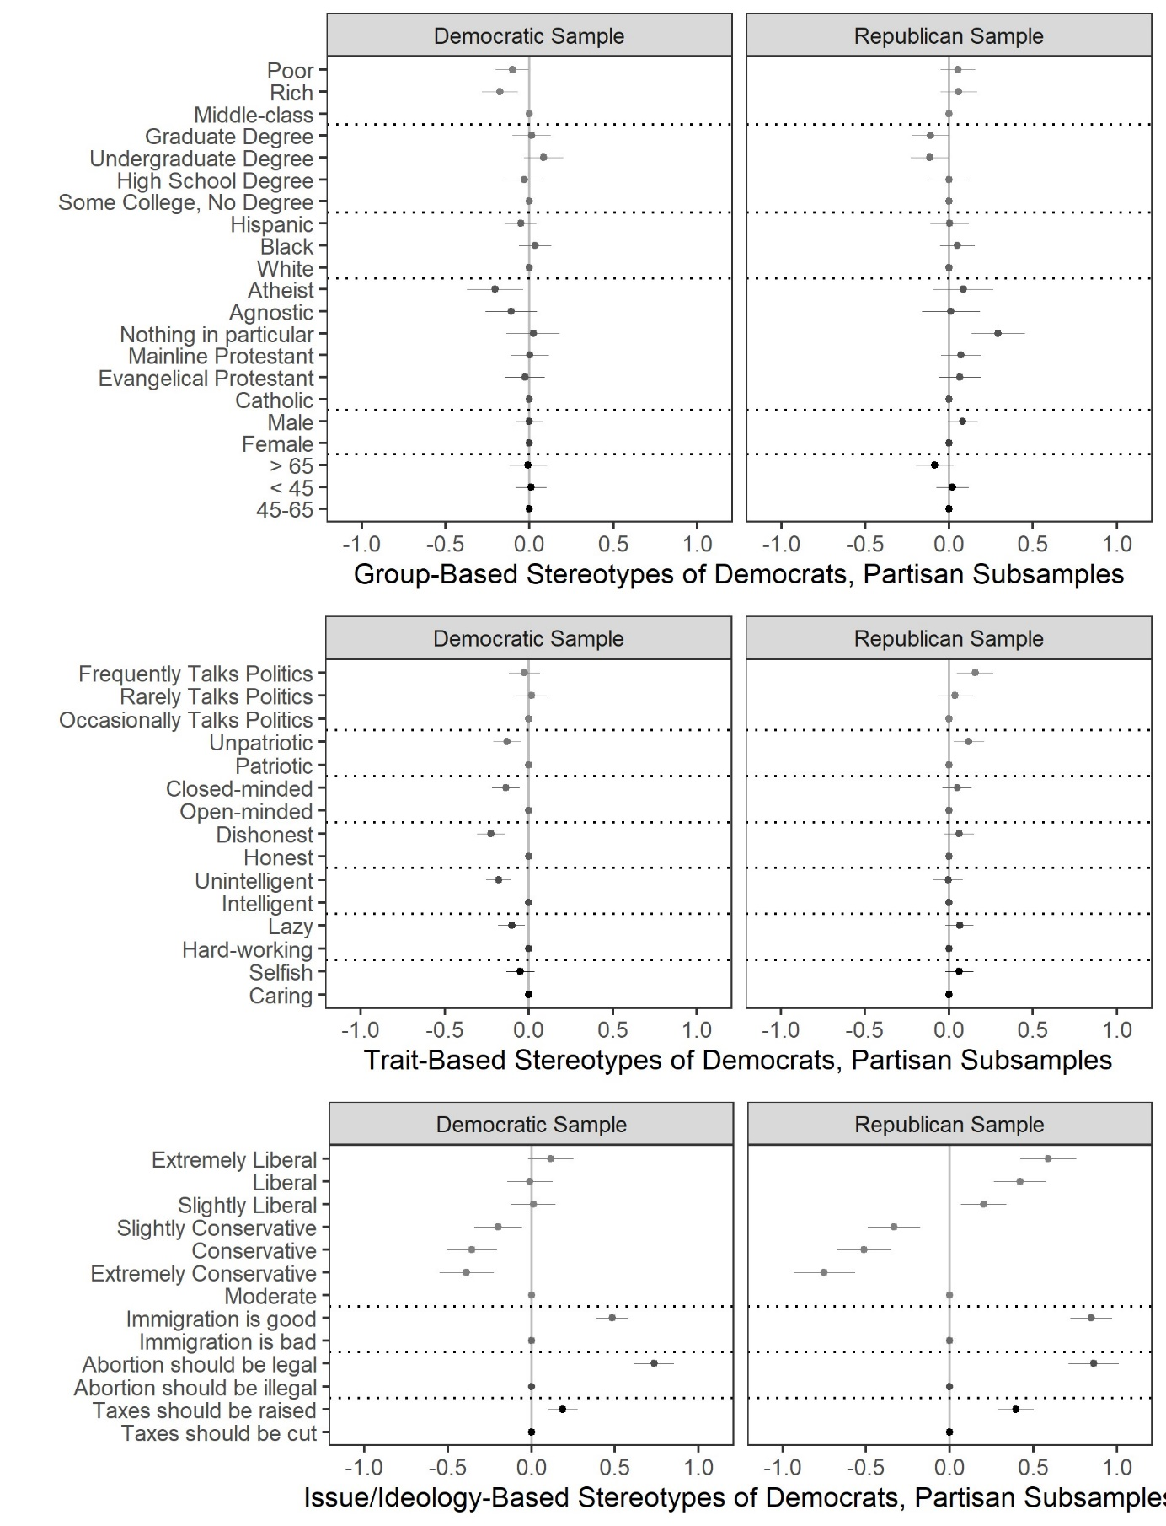Figure 4: Content of Stereotypes of Democrats by Partisan Subsample. The AMCE of each attribute for respondents asked to rate the typicality of Democrats, with separate plots for Democratic respondents and Republican respondents. For both partisan subsamples the AMCEs for ideological labels and issue positions are larger than those for issues or groups.
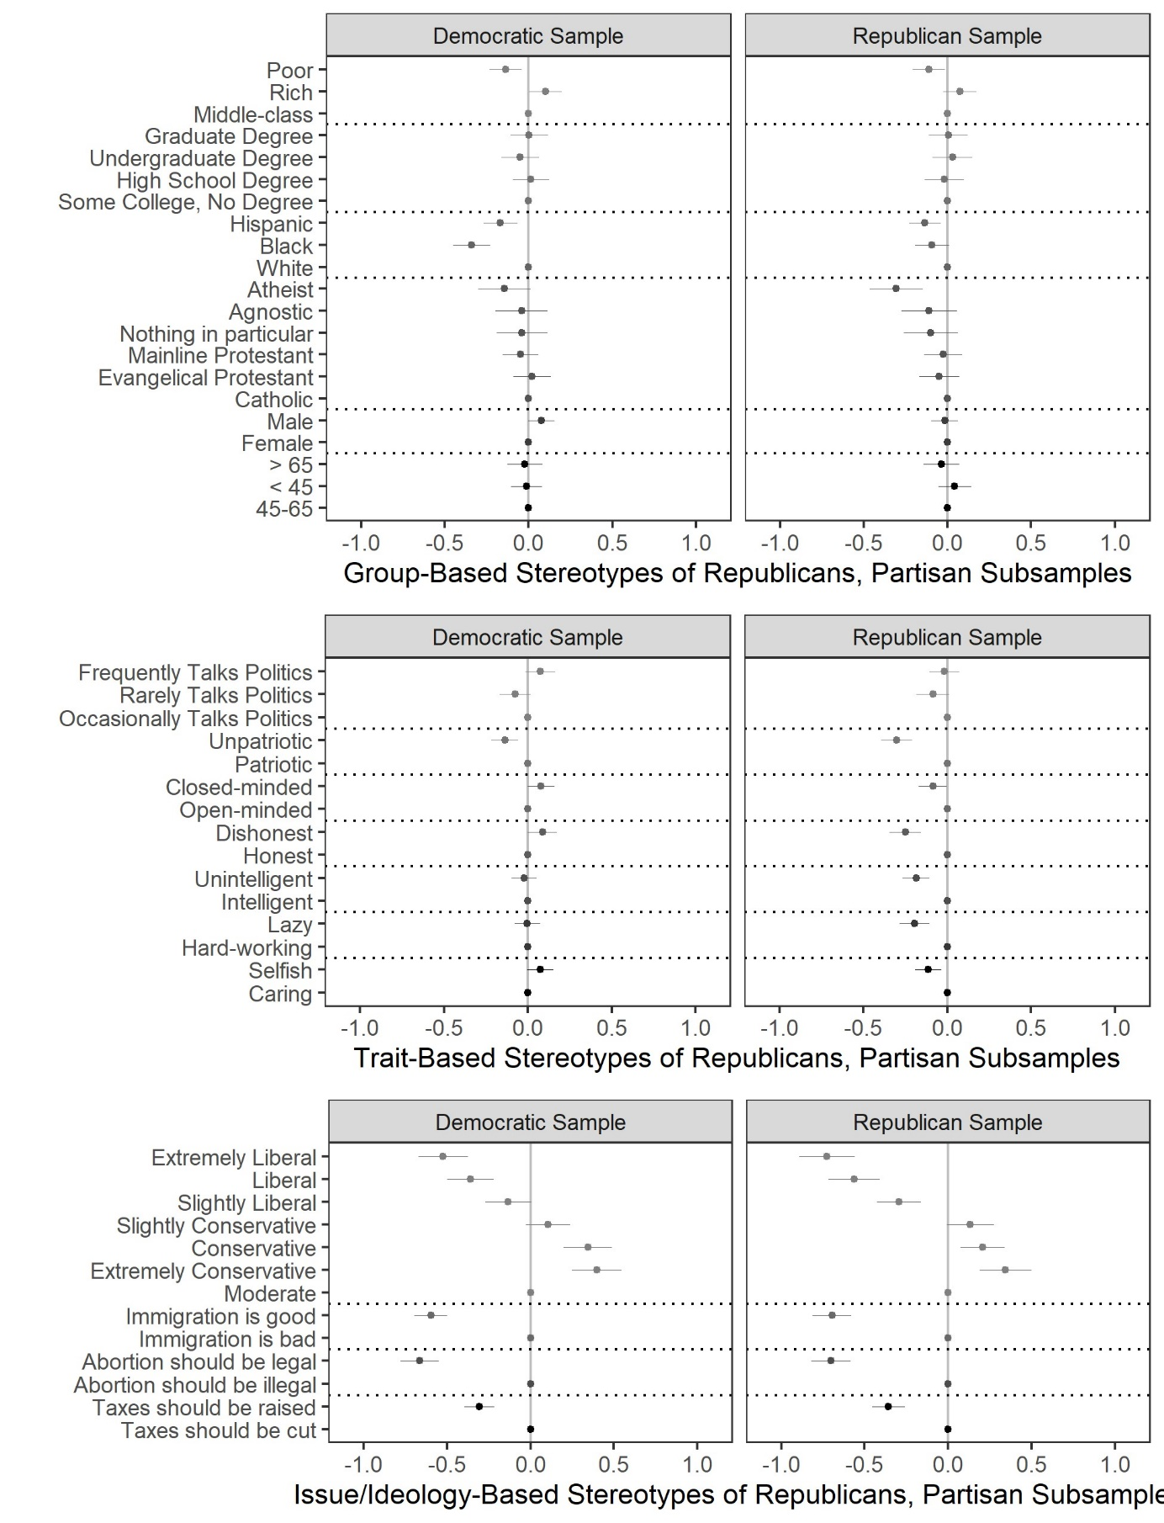
Figure 5: Content of Stereotypes of Republicans by Partisan Subsample. The AMCE of each attribute for respondents asked to rate the typicality of Republicans, with separate plots for Democratic respondents and Republican respondents. For both partisan subsamples the AMCEs for ideological labels and issue positions are larger than those for issues or groups.

Examining the effects of individual attributes appears to validate the “issues” theory of partisan stereotypes. To formally test this, Appendix C reports Vuong tests comparting the fit of four models for stereotypes of each party, one containing each type of attribute. For stereotypes of both parties in the full sample and both subsamples the “issues” model has a significantly better fit than any other model. The “ideology” model provides the second-best fit. The fit of the “groups” and “traits” models are indistinguishable in the full sample, but for each partisan subsample traits are more important to the stereotypes of the in-party while groups are more important to the stereotype of the out-party. In sum, the results of these comparisons of model fit confirm the impression produced by Figures 1-4: issue positions are clearly the most central element of partisan stereotypes, followed by ideological labels, and both of these are significantly more central than either traits or groups.

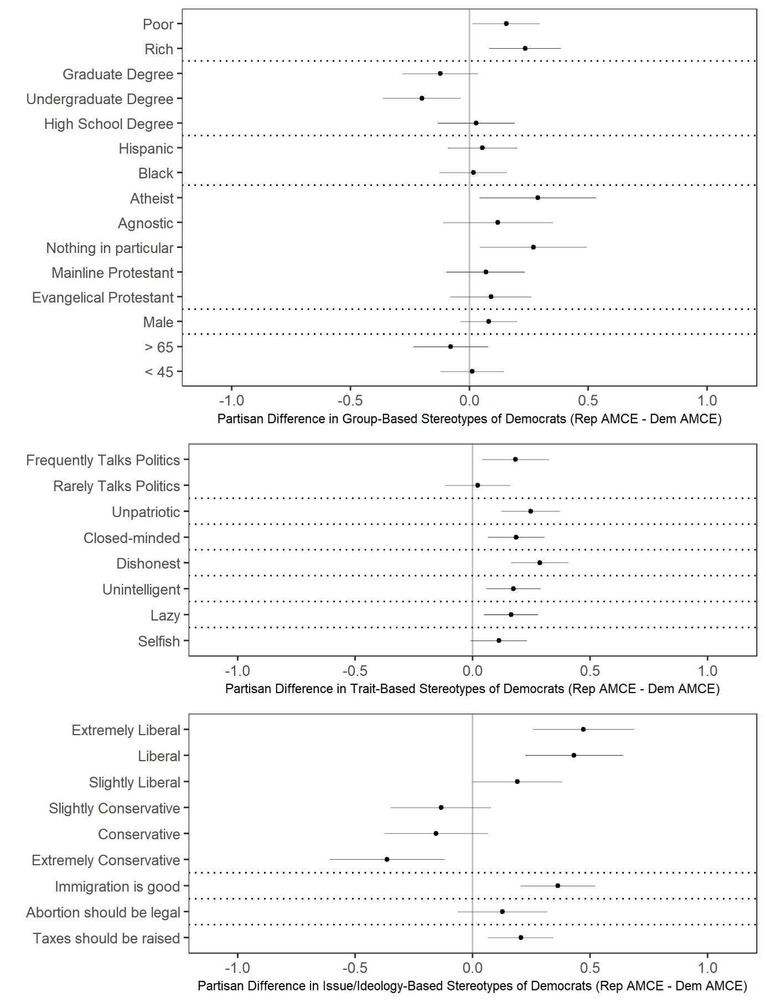
Figure 6: Differences Between Republicans’ and Democrats’ Stereotypes of Democrats. The difference in AMCEs among Republicans and Democrats asked to rate the typicality of Democrats. Republican respondents judged liberal and extremely liberal profiles as more typical of Democrats than did Democrats.
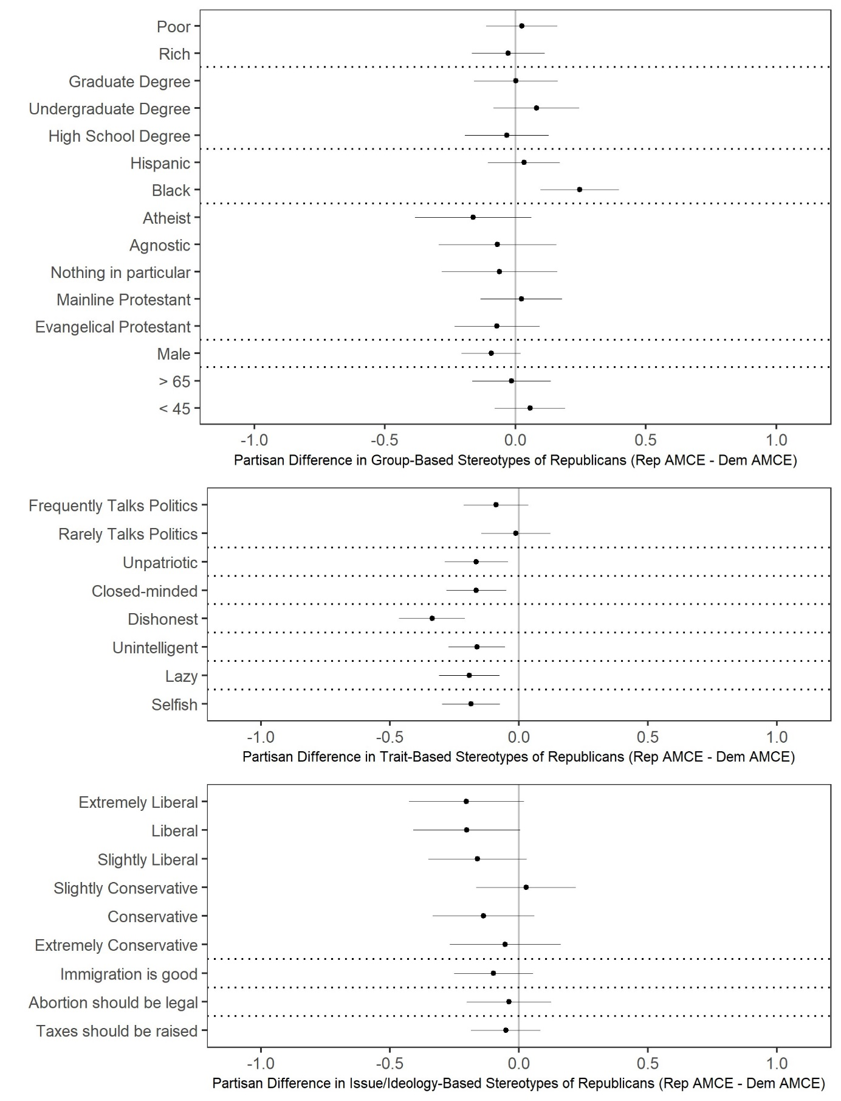
Figure 7: Differences Between Republicans’ and Democrats’ Stereotypes of Republicans. The difference in AMCEs among Republicans and Democrats asked to rate the typicality of Republicans. There were minimal significant differences between partisans’ stereotypes of Republicans.
Analyses of Individual-Level Stereotypes
In addition to these results, Appendix D and E report pre-registered analyses of the correlates on holding different stereotypes at the individual level and of the relationship between holding different stereotypes and ideological, perceived, and affective polarization. Briefly, we find few significant demographic predictors of holding any particular stereotype. We find that high levels of knowledge and interest predict stronger stereotypes in terms of ideology and issue positions, but we find no relationship between sophistication and stereotypes in terms of groups or traits. We find that stereotyping the parties in terms of issues and ideology is associated with higher levels of perceived and affective polarization, even in models that include controls for demographics and political sophistication.

Conclusion

If partisanship is primarily social identification, then individuals’ images of the parties play a critical role in political behavior. An individuals’ stereotypes of the parties affect perceptions of the parties as social groups, allow the individual to categorize other individuals as in-partisans or out-partisans and draw inferences from this categorization, and determine how an individual’s partisanship will shape their beliefs, behaviors, and non-partisan social identifications. Through these mechanisms, stereotypes play a role in affective polarization, social and ideological sorting, and social interaction between partisans.
Political scientists have recognized the role of partisan stereotypes in the development and effects of partisanship. As Green et al. (2002, pg. 8) say, “As people reflect on whether they are Democrats or Republicans (or neither), they call to mind some mental image, or stereotype, of what these sorts of people are like.” Yet, a long tradition in political science simply assumes that these images are rooted in social groups. Green et al. continue: “[P]eople ask themselves … [w]hat kinds of social groups come to mind as I think about Democrats, Republicans, and Independents?” This assumption that parties’ constituent social groups are the central, or even sole, element of individuals’ stereotypes of the parties underlies the recent move towards a group-based understanding of mass politics, and away from an understanding rooted in ideology or issue positions (Achen and Bartels 2016; Mason 2018; Kane et al. 2021).
We suggest that this assumption is incorrect. Using a conjoint experiment, we compare the centrality of different attributes, and different kinds of attributes, to partisan stereotypes. While using conjoint experiments to measure stereotype content is relatively new, this method builds on a long-established paradigm in social psychology that measures stereotype content by asking respondents to judge the typicality of individual exemplars. We find limited evidence that groups or traits play a central role in stereotypes of partisans. Instead, we find strong evidence that positions on high-profile issues and ideological labels are the central attributes of partisan stereotypes. Put differently, when people picture the two parties, they are much more likely to picture an anti-abortion conservative or a pro-immigration liberal than an elderly Evangelical or a young, Black woman.
Why do these results differ from other work that places social groups at center of individuals’ perceptions of the two parties? Most existing studies examine perceptions of the parties in terms of one, or one kind, of attribute, and measure perceptions using direct questioning. Asking about individual attributes in isolation may measure the effects of not just that attribute, but also of other attributes that are part of the individuals’ stereotypes of the parties. For example, asking about Evangelical Christians may bring to mind an image of people who are opposed to abortion. In this case, the reported effect of perceptions of Republicans as Evangelical Christians will be a combination of the effect of stereotyping Republicans as Evangelical Christians and the effect of stereotyping Republicans as being pro-life. By simultaneously measuring the impact of multiple attributes, conjoint experiments avoid this problem. Direct questioning may also artificially inflate the importance of an attribute by temporarily increasing its salience.
While our results suggest that issues and ideological labels play a larger role in American politics than some group-based explanations suggest, we do not take this as evidence that most Americans think about politics in terms of clearly defined ideologies (Converse 1964; Kinder and Kalmoe 2017). As we note above, the existing literature has treated ideological labels variously as indicators of issue positions, as groups that individuals may identify with, and as traits – indeed, Busby et al. (2021) suggest that the members of the mass public think of “liberal” and “conservative” as all three of these things. Similarly, the issue positions used here may serve as signifiers of identity; for example, knowing that a woman is pro-choice may communicate information about what kind of woman she is (Klar 2018). Nevertheless, this is a different kind of group identity, one infused with more political content than the group identities commonly discussed in the literature. Picturing a conservative anti-immigrant Republican or a liberal, pro-choice Democrat is different from picturing “a Southern, evangelical Republican or a young, nonwhite Democrat” (Ahler and Sood 2018, pg. 965) even if “conservative” and “liberal” lack coherent ideological content.
We also find that issue and ideology-based stereotypes are more strongly associated with polarization - ideological, perceived, and affective - than trait or group-based stereotypes. It is perhaps unsurprising that individuals who stereotype the two parties in terms of issues and ideology also hold more ideologically extreme positions and perceive more ideological polarization between the parties. However, recent literature suggests that affective polarization is driven by seeing parties as constellations of disliked groups (Mason 2018), or as social groups associated with disliked traits (Busby et al. 2021). Our finding echoes other work that blames affective polarization on ideological polarization (Bougher 2017; Webster and Abramowitz 2017). This is not necessarily inconsistent with the idea that increased social identification with a political party is associated with affective polarization, but it suggests that this connection is driven by a sense that the two parties hold different positions on high-profile issues, not that they consist of different social groups. Importantly, these results are descriptive, not causal; it is possible that more affectively polarized individuals develop issue-based stereotype instead of the other way around.
This study has several limitations. First, the profiles in this study are presented in a relatively context-free manner. When individuals actually use stereotypes, contextual factors likely increase or decrees the importance of some attributes, and future work should examine such contextual factors. Relatedly, the profiles presented here include the full set of information about the individual described, including attributes that may not be readily observable in unknown individuals such as issue positions or traits like honesty. When using stereotypes to categorize unknown individuals, the perceiver must rely on observable information, which is more likely to include information about “group” attributes (e.g. race) than trait or issue attributes. However, we would argue that the “full stereotype” measured here is the relevant mental object for other functions of stereotypes, such as self-stereotyping or determining affect towards the out-party.
Second, these stereotypes measured here should be considered cross-sectional snapshots. While stereotypes show remarkable stability over time (Garcia-Marques et al. 2017), individuals’ stereotypes respond to contextual and motivational factors driven, for example, by current events. At the aggregate level, long-term trends can change the content of stereotypes or make some aspects more salient that others. We would not expect the major news storis during this study period, inflation and the Omicron wave, to have short-term effects on the AMCEs of the attributes included in this study. However, partisan sorting and elite ideological polarization may mean that issues and ideological labels play a more central role in partisan stereotypes than they would have at other points in American history. Other work using other methods has documented changes in party stereotypes over time (Busby, Howat, and Myers 2022), but future work should examine how these broader contextual factors affect the content of partisan stereotypes.
Finally, while the conjoint measure allows the inclusion of many more attributes than most direct questioning techniques, the design still excludes some attributes that potentially play a role in partisan stereotypes. The conjoint design can include many attributes, but readers could doubtless suggest dozens of others, including group-attributes like sexual orientation, traits like “traditional,” or other issue positions. We include those attributes that previous work, theory, and open-ended data collection suggest are most important. We think it unlikely, though certainly possible, that some unincluded attribute would be sufficiently influential to overturn our basic finding. A related concern is that the fact that we include only three issues means that the issues we selected might stand in for positions on economic, social, and “populist” issues more generally. For example, respondents might infer that a profile that is opposed to abortion is also opposed to gay marriage, and rate the profile partially based on this inference. Nevertheless, this concern should not affect our general finding that issues in general are more important than group or trait attributes.
Alternately, perhaps some kind of attribute beyond groups/issues/traits that is central to the partisan stereotype. For example, recent work suggests that core human values underlie partisanship (Goren, Smith, and Motta 2020); perhaps they are also central elements of partisan stereotypes. We focus on the most prominent competing theories of partisan stereotypes, but future work should examine whether other kinds of attributes play an important role in stereotypes of partisans.

Data Availability Statement: REPLICATION DATA AND DOCUMENTATION are available at ADD IN FINAL URL HERE.
Bibliography
Abramowitz, Alan I., and Kyle L. Saunders. 2006. “Exploring the Bases of Partisanship in the American Electorate: Social Identity vs. Ideology.” Political Research Quarterly 59: 175–87.

Achen, Christopher H., and Larry M. Bartels. 2016. Democracy for Realists: Why Elections Do Not Produce Responsive Government. Princeton, New Jersey: Princeton University Press.

Ahler, Douglas J., and Gaurav Sood. 2018. “The Parties in Our Heads: Misperceptions about Party Composition and Their Consequences.” The Journal of Politics 80: 964–81.

Bansak, Kirk, Jens Hainmueller, Daniel J. Hopkins, and Teppei Yamamoto. 2018. “The Number of Choice Tasks and Survey Satisficing in Conjoint Experiments.” Political Analysis 26: 112–19.

Bodenhausen, Galen V., Sonia K. Kang, and Destiny Peery. 2012. “Social Categorization and the Perception of Social Groups.” In The SAGE Handbook of Social Cognition, eds. Susan T. Fiske and C. Neil Macrae. SAGE, 311–29.

Bougher, Lori D. 2017. “The Correlates of Discord: Identity, Issue Alignment, and Political Hostility in Polarized America.” Political Behavior 39: 731–62.

Busby, Ethan C., Adam J. Howat, Jacob E. Rothschild, and Richard M. Shafranek. 2021. The Partisan Next Door: Stereotypes of Party Supporters and Consequences for Polarization in America. Cambridge University Press.

Busby, Ethan C., Adam J. Howat, and C. Daniel Myers. 2022. “Changing Partisan Stereotypes 2016-2021.” Paper Presented at the 79th Annual MPSA Conference, 2022, Chicago, IL.

Campbell, Angus, Philip E. Converse, Warren E. Miller, and Donald E. Stokes. 1960. The American Voter. University of Chicago Press.

Claassen, Ryan L., Paul A. Djupe, Andrew R. Lewis, and Jacob R. Neiheisel. 2021. “Which Party Represents My Group? The Group Foundations of Partisan Choice and Polarization.” Political Behavior 43: 615–36.

Clifford, Scott. (2020). Compassionate Democrats and Tough Republicans: How Ideology Shapes Partisan Stereotypes. Political Behavior 42: 1269–1293.

Converse, Philip E. 1964. “The Nature of Belief Systems in Mass Publics.” In Ideology and Its Discontents, ed. David E. Apter. New York: Free Press.

Coppock, Alexander, and Oliver A. McClellan. 2019. “Validating the Demographic, Political, Psychological, and Experimental Results Obtained from a New Source of Online Survey Respondents.” Research & Politics 6. DOI: 10.1177/2053168018822174

Costa, Mia. 2021. “Ideology, Not Affect: What Americans Want from Political Representation.” American Journal of Political Science 65: 342–58.

Dafoe, Allan, Baobao Zhang, and Devin Caughey. 2018. “Information Equivalence in Survey Experiments.” Political Analysis 26: 399–416.

Diekman, Amanda B., and Alice H. Eagly. 2000. “Stereotypes as Dynamic Constructs: Women and Men of the Past, Present, and Future.” Personality and Social Psychology Bulletin 26: 1171–88.

Druckman, James N. Samara Klar, Yanna Krupnikov, Matthew Levendusky, and John B. Ryan. 2022. “(Mis)Estimating Affective Polarization.” The Journal of Politics 84: 1106–17.

Ellis, Christopher, and James A. Stimson. 2012. Ideology in America. Cambridge University Press.

Esses, Victoria M., Geoffrey Haddock, and Mark P. Zanna. 1993. “Values, Stereotypes, and Emotions as Determinants of Intergroup Attitudes.” In Affect, Cognition, and Stereotyping: Interactive Processes in Group Perception, eds. Diane M. Mackie and David L. Hamilton. San Diego: Academic Press, 137–66.

Flores, René D., and Ariela Schachter. 2018. “Who Are the ‘Illegals’? The Social Construction of Illegality in the United States.” American Sociological Review 83: 839–68.

Gallup. 2021. “Most Important Problem.” Gallup.com. https://news.gallup.com/poll/1675/Most-Important-Problem.aspx (April 5, 2021). Archived at http://web.archive.org/web/20220405232106/https://news.gallup.com/poll/1675/most-important-problem.aspx

Garcia-Marques, Leonel, A. Sofia C. Santos, and Diane M. Mackie. 2006. “Stereotypes: Static Abstractions or Dynamic Knowledge Structures?” Journal of Personality and Social Psychology 91: 814–31.

Garcia-Marques, Leonel, Ana Sofia Santos, Diane M. Mackie, Sara Hagá, and Tomás A. Palma. 2017. “Cognitive Malleability and the Wisdom of Independent Aggregation.” Psychological Inquiry 28: 262–67.

Goggin, Stephen N., and Alexander G. Theodoridis. 2017. “Disputed Ownership: Parties, Issues, and Traits in the Minds of Voters.” Political Behavior 39: 675–702.

Goggin, Stephen N., John A. Henderson, and Alexander G. Theodoridis. 2020. “What Goes with Red and Blue? Mapping Partisan and Ideological Associations in the Minds of Voters.” Political Behavior 42: 985–1013.

Goldman, Seth K., and Diana Carole Mutz. 2014. The Obama Effect: How the 2008 Campaign Changed White Racial Attitudes. New York: Russell Sage Foundation.

Goren, Paul, Brianna Smith, and Matthew Motta. 2020. “Human Values and Sophistication Interaction Theory.” Political Behavior 44: 49–73.

Green, Donald P., Bradley Palmquist, and Eric Schickler. 2002. Partisan Hearts and Minds: Political Parties and the Social Identities of Voters. New Haven: Yale University Press.

Greene, Steven. 2004. “Social Identity Theory and Party Identification.” Social Science Quarterly 85: 136–53.

Hainmueller, Jens, Daniel J. Hopkins, and Teppei Yamamoto. 2014. “Causal Inference in Conjoint Analysis: Understanding Multidimensional Choices via Stated Preference Experiments.” Political Analysis 22: 1–30.

Han, Jiyoung, and Daniel B. Wackman. 2017. “Partisan Self-Stereotyping: Testing the Salience Hypothesis in a Prediction of Political Polarization.” International Journal of Communication 11: 603-625.

Hayes, Danny. 2005. “Candidate Qualities through a Partisan Lens: A Theory of Trait Ownership.” American Journal of Political Science 49: 908–23.

Heit, Evan, and Stephen P. Nicholson. 2010. “The Opposite of Republican: Polarization and Political Categorization.” Cognitive Science 34: 1503–16.

Horiuchi, Yusaku, Zachary Markovich, and Teppei Yamamoto. 2021. “Does Conjoint Analysis Mitigate Social Desirability Bias?” Political Analysis: 1–15.

Iyengar, Shanto, Gaurav Sood, and Yphtach Lelkes. 2012. “Affect, Not Ideology: A Social Identity Perspective on Polarization.” Public Opinion Quarterly 76: 405–31.

Iyengar, Shanto, Yphtach Lelkes, Matthew Levendusky, Neil Malhotra, and Sean J. Westwood. 2019. “The Origins and Consequences of Affective Polarization in the United States.” Annual Review of Political Science 22: 129–46.

Kalmoe, Nathan P. 2020. “Uses and Abuses of Ideology in Political Psychology.” Political Psychology 41: 771–93.

Kane, John Victor, Lilliana Mason, and Julie Wronski. 2021. “Who’s at The Party? Group Sentiments, Knowledge, and Partisan Identity.” The Journal of Politics 83: 1783-1799

Katz, D., and K. Braly. 1933. “Racial Stereotypes of One Hundred College Students.” Journal of Abnormal and Social Psychology 28: 280-290.

Kinder, Donald R., and Nathan P. Kalmoe. 2017. Neither Liberal nor Conservative: Ideological Innocence in the American Public. Chicago: University of Chicago Press.

Kennedy, Courtney, Nicholas Hatley, Arnold Lau, Andrew Mercer, Scott Keeter, Joshua Ferno, and Dorene Asare-Marfo. 2021. “Strategies for Detecting Insincere Respondents in Online Polling.” Public Opinion Quarterly 85: 1050–75.

Klar, Samara. 2018. “When Common Identities Decrease Trust: An Experimental Study of Partisan Women.” American Journal of Political Science 62(3): 610–22.

Lee, Amber Hye-Yon. 2021. “How the Politicization of Everyday Activities Affects the Public Sphere: The Effects of Partisan Stereotypes on Cross-Cutting Interactions.” Political Communication 38: 499–518.

Lelkes, Yphtach. 2021. “Policy over Party: Comparing the Effects of Candidate Ideology and Party on Affective Polarization.” Political Science Research and Methods 9: 189–96.

Margolis, Michele F. 2018. “How Far Does Social Group Influence Reach? Identities, Elites, and Immigration Attitudes.” Journal of Politics 8: 772–85.

Mason, Lilliana. 2018. Uncivil Agreement: How Politics Became Our Identity. Chicago, Illinois: University of Chicago Press.

Mason, Lilliana, and Julie Wronski. 2018. “One Tribe to Bind Them All: How Our Social Group Attachments Strengthen Partisanship.” Political Psychology 39(S1): 257–77.

Myers, C. Daniel, Kirill Zhirkov, and Kristin Lunz Trujillo. 2022. “Who Is ‘On Welfare’? Validating the Use of Conjoint Experiments to Measure Stereotype Content.” Political Behavior. DOI: 10.1007/s11109-022-09815-0

Nicholson, Stephen P., Christopher J. Carman, Chelsea M. Coe, Aidan Feeney, and Fehér, Balázs, Brett K. Hayes, Christopher Kam, Jeffrey A. Karp, Gergo Vaczi, and Evan Heit. 2018. “The Nature of Party Categories in Two-Party and Multiparty Systems.” Advances in Political Psychology 39: 279–304.

Niemi, Richard G., and M. Kent Jennings. 1991. “Issues and Inheritance in the Formation of Party Identification.” American Journal of Political Science 35: 970–88.

Ogura, Ikuma, Hirofumi Miwa, and Takeshi Iida. 2022. “What Do You Mean by ‘Democrat’ and ‘Republican’? Evidence from a Conjoint Experiment.” International Journal of Public Opinion Research 34: 1-14.

Orr, Lilla V., and Gregory A. Huber. 2020. “The Policy Basis of Measured Partisan Animosity in the United States.” American Journal of Political Science 64: 569–86.

Orr, Lilla V, and Gregory A Huber. 2021. “Measuring Misperceptions: Limits of Party-Specific Stereotype Reports.” Public Opinion Quarterly 85: 1076–91.

Patrikios, Stratos. 2013. “Self-Stereotyping as ‘Evangelical Republican’: An Empirical Test.” Politics and Religion 6: 800–822.

Petrocik, John R. 1996. “Issue Ownership in Presidential Elections, with a 1980 Case Study.” American Journal of Political Science 40(3): 825–50.

Popkin, Samuel L. 1991. The Reasoning Voter: Communication and Persuasion in Presidential Campaigns. Chicago: University of Chicago Press.

Rahn, Wendy M. 1993. “The Role of Partisan Stereotypes in Information Processing about Political Candidates.” American Journal of Political Science 37(2): 472–96.

Robison, Joshua, and Rachel L. Moskowitz. 2019. “The Group Basis of Partisan Affective Polarization.” Journal of Politics 81: 1075–79.

Rothschild, Jacob E., Adam J. Howat, Richard M. Shafranek, and Ethan C. Busby. 2019. “Pigeonholing Partisans: Stereotypes of Party Supporters and Partisan Polarization.” Political Behavior 41: 423–43.

Turner, John C. 1987. Rediscovering the Social Group: A Self-Categorization Theory. New York: Blackwell.

Vuong, Quang H. 1989. “Likelihood Ratio Tests for Model Selection and Non-Nested Hypotheses.” Econometrica 57: 307–33.

Webster, Steven W., and Alan I. Abramowitz. 2017. “The Ideological Foundations of Affective Polarization in the U.S. Electorate.” American Politics Research 45: 621–47.

Zhirkov, Kirill. 2022. “Estimating and Using Individual Marginal Component Effects from Conjoint Experiments.” Political Analysis 30: 236-249.

Pre-registration: https://doi.org/10.17605/OSF.IO/QUPVS
Bansak et al. (2018) find that respondents can compete this many conjoint tasks without degrading data quality. Question text is taken from Myers et al. (2022)’s validation of the conjoint measure of stereotype content.
Appendix A reports results from a 2018 pilot study that employed both question formats and found no substantive difference. Appendix I shows results from the current study with responses re-coded into a choice-like dichotomous variable.
Appendix J reports a non-preregistered analysis of whether holding ideologically consistent issue positions affected judgements of typicality. We find no evidence of this.
Notably, however, being Evangelical is not significantly associated with being a Republican, except in comparison to atheists, and not particularly disassociated with being a Democrat. The recent polarization of voters by education level and age also does not seem to have affected respondents’ stereotypes.
We present results for partisan subsamples because an F-test finds a significant difference between Republicans’ and Democrats’ stereotypes (Democrats: F = 7.80, p < .001; Republicans: F = 31.77, p < .001).
Our pre-registration specifies conducting these tests with a Bonferroni corrected α = .00294. For ease of comparison between Figures, we show results with α = .05. Appendix F shows the same figures with the pre-registered α level; few differences change from statistically significant to statistically insignificant.
Appendix G presents a non-pre-registered analysis that tests whether stereotypes differ between high and low-knowledge and interest respondents. We find that the magnitude of AMCEs among the highly engaged is larger, but the content of these stereotypes is substantively similar across levels of engagement.
For example, Goldman and Mutz (2014)’s find that Obama’s Presidential campaign changed whites’ stereotypes of African-Americans, but that this effect faded after the campaign ended.
The only major news story during this period that was directly related to one of the study’s attributes were the Dobbs oral arguments; these concluded three days before data collection began and did not appear to increase the salience of abortion (Gallup 2021).
A related concern is our use of a non-probability sample, which may raise concerns about response quality (Kennedy et al. 2021) and representativeness in terms of political engagement (Kalmoe 2020). Appendix G shows that our core finding holds across levels of political knowledge and interest, Appendix L details our attention checks, and Appendix A reports substantively similar results from a 2018 pilot study using a different convenience sample. Still, care should be taken in generalizing from these findings, which should be replicated with other samples.

